31.51: a) At resonance, 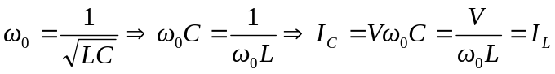 so 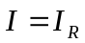 and I is a minimum.
b) 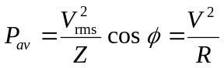 at resonance where R < Z so power is a maximum.
c) At 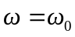, I and V are in phase, so the phase angle is zero, which is the same as a series resonance.

